OpenCart

## FUNCTIONALITY REQUIREMENTS

#### (FRONT END)

OVERVIEW :

OpenCart is free open source e-commerce platform for online merchants. OpenCart provides a professional and reliable foundation from which to build a successful online store. The objective of this e-commerce project is to develop a user-friendly and secure online shopping platform for customers to browse, purchase and track their orders.

**The application will include features such as user registration and login, product catalog, shopping cart, checkout, payments gateway integration, and order management.**

**NOTE** - Requirements documentation contains details on user stories, test cases, and design mockups to each requirement to provide more clarity and context for the development team.

The project will aim to provide a seamless user experience and ensure the security of sensitive customer information. The target audience for this e-commerce platform will be customers looking to purchase a wide variety of products online.

**REGISTRATION** :

**User Stories**

* **As a new user, I want to be able to easily create a new account and register for the platform**

**Acceptance Criteria**

* + - * Users should be able to register for a new account.
      * User can access the registration page from the homepage.
      * User can enter their details (name, email, password, etc.) and click the "register" button.
      * User is redirected to their account dashboard upon successful registration.

**Design Mockups**

Registration page design mockup

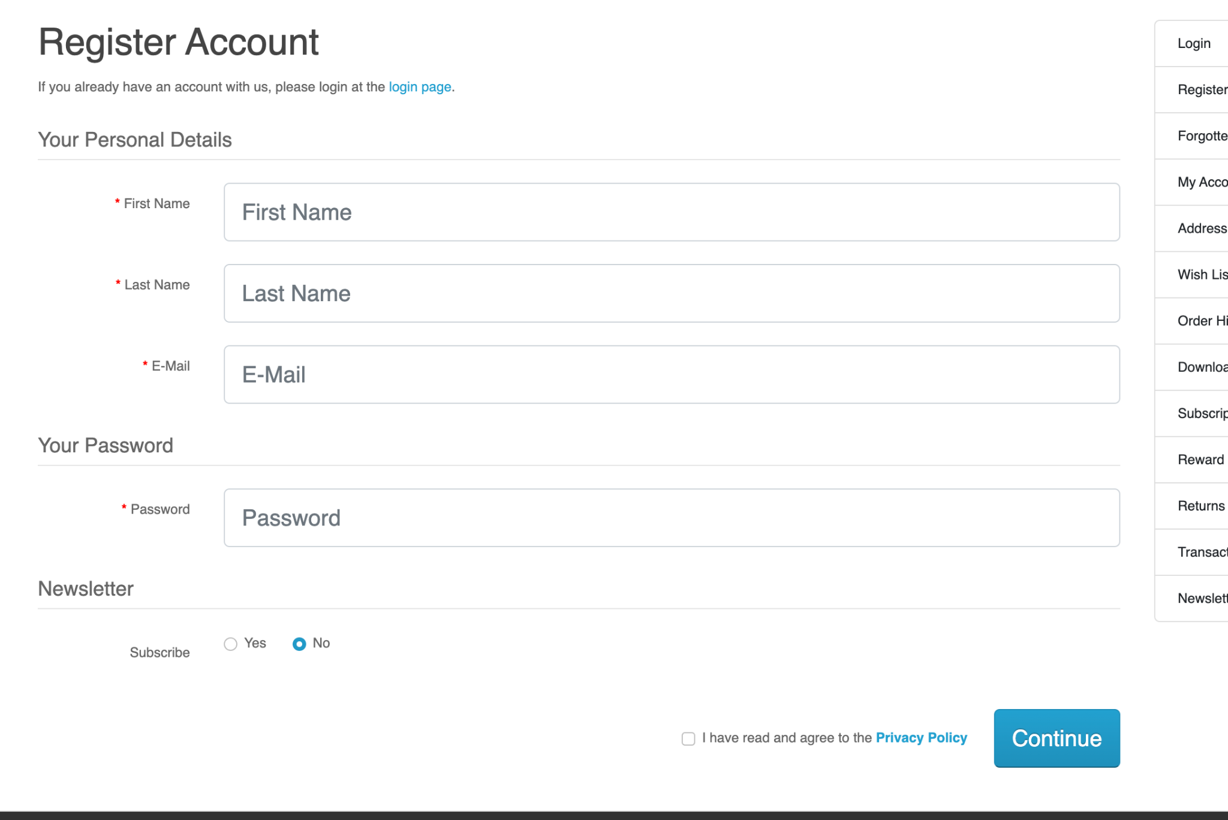

**USER LOGIN** :

**User Stories**

* **As an existing user, I want to be able to login to my account, with my valid credentials.**

**Acceptance Criteria**

* + - * Users should be able to create an account and log in to the system.
      * User can access the login page from the homepage.
      * User can enter their credentials and click the "login" button.
      * User is redirected to their account dashboard upon successful login.

**Design Mockups**

Login page design mockup

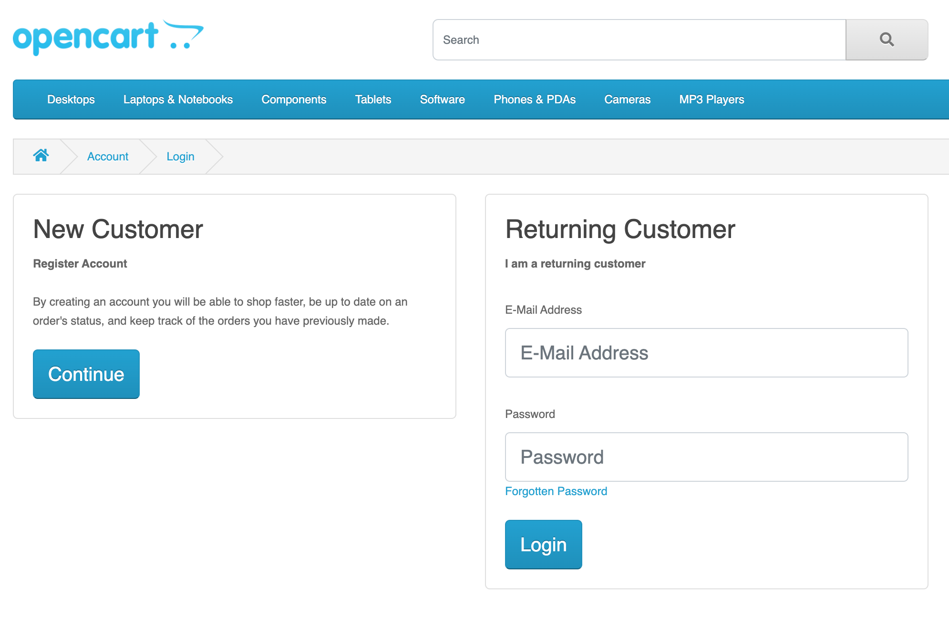

**ADD TO CART** :

**User Stories**

* **As a customer, I want to be able to easily add products to my cart and view my cart.**
* **As a customer, I want to be able to easily manage the contents of my cart.**

**Acceptance Criteria**

* Users should be able to add products to their cart.
* User can click the "Add to Cart" button on a product page.
* The product is added to the user's cart.
* User can view their cart and the products they have added.

**Design Mockups**

Product page design mockup with Add to Cart button

Cart page design mockup

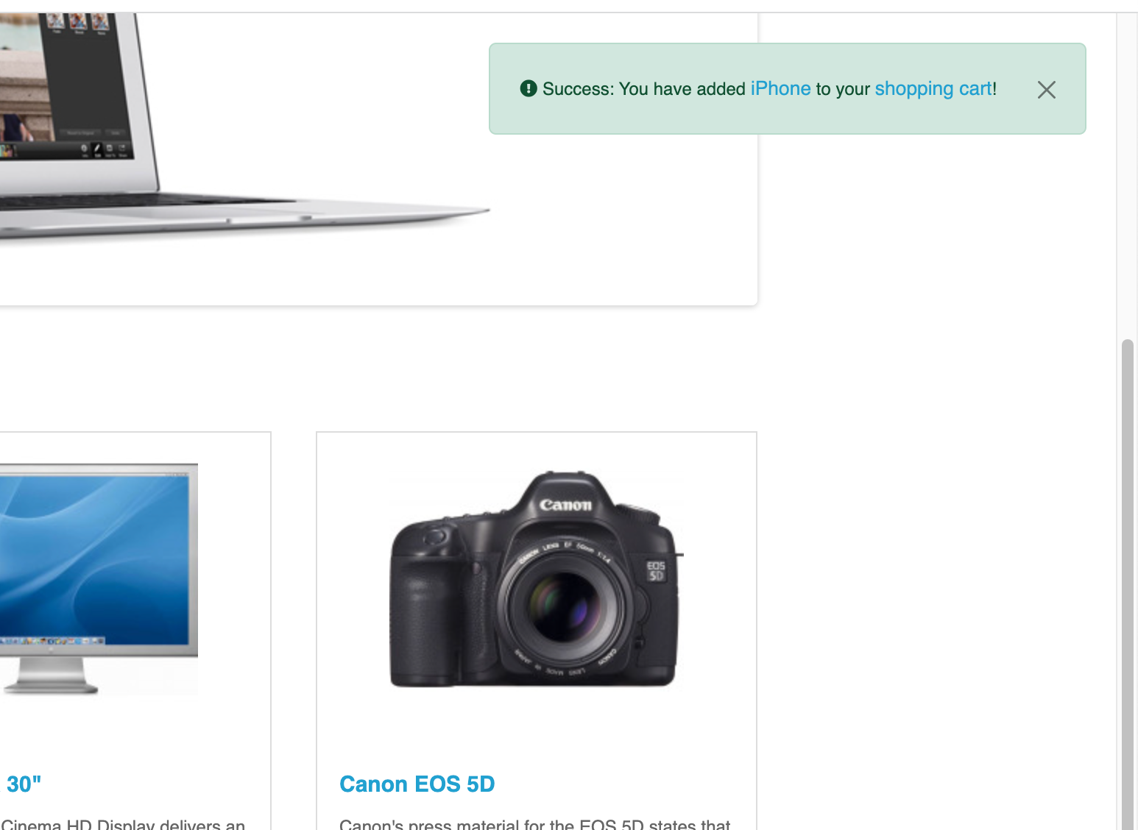

**CHECK OUT :**

**User Stories**

* **As a customer, I want to be able to easily complete my purchase and provide my payment information.**
* **As a customer, I want to be able to view my order summary and confirm my purchase.**

**Acceptance Criteria**

* Users should be able to complete a purchase.
* User can click the "Checkout" button from their cart page.
* User can enter their shipping and billing information.
* User can choose a payment method and complete the transaction**.**

**Design Mockups**

Check out page design mockup

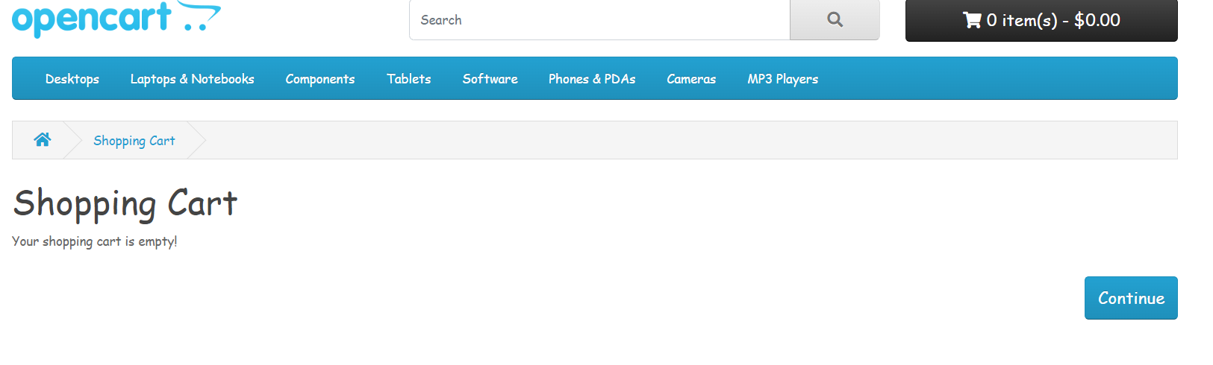

**PAYMENT GATEWAY :**

**User Stories**

* **As a customer, I want to be able to choose from a variety of payment methods and securely enter my payment information.**
* **As a platform, we want to ensure the security of customer payment information and provide a seamless payment experience.**

**Acceptance Criteria**

* The system should integrate with a payment gateway.
* User can choose from a list of supported payment methods during checkout.
* User's payment information is securely transmitted to the payment gateway for processing.

**ORDERS :**

**User Stories**

* **As a customer, I want to be able to view my order history and track the status of my orders.**
* **As a platform, we want to be able to manage and fulfill customer orders efficiently.**

**Acceptance Criteria**

* Users should be able to view their order history.
* User can access their order history from their account dashboard.
* User can view details about their past orders (date, products purchased, total cost, etc.).